Lab 3

Michael Austin

# Part I

Using http_ethereal_trace_1 and 2.

1. Is your browser running HTTP version 1.0 or 1.1? What version of HTTP is the server running?

**1.1**

1. What languages (if any) does your browser indicate that it can accept to the server?

**en-us**

1. What is the IP address of your computer? Of the gaia.cs.umass.edu server?

My personal IP address: **73.236.113.6**

Source computer from ethereal_trace_1: **192.168.1.102**

Destination computer from ethereal_trace_1: **128.119.245.12**

1. What is the status code returned from the server to your browser?

**The text/html response to the browser was 200 OK**

**The favicon response was 404 NOT FOUND**

1. When was the HTML file that you are retrieving last modified at the server?

**Tuesday 23rd September, 2003 05:29:00 GMT**

1. How many bytes of content are being returned to your browser?

**555**

1. Inspect the contents of the first HTTP GET request from your browser to the server. Do you see an “IF-MODIFIED-SINCE” line in the HTTP GET?

**Yes, in the ethereal_trace_2.**

**Date: Tuesday 23rd September, 2003. 05:35:00 GMT**

1. Inspect the contents of the server response. Did the server explicitly return the contents of the file? How can you tell?

**Yes? The server returned an html page that stated “Congratulations! You’ve downloaded the file lab-2-2.html.”**

**It also included information about the download status and IN-MODIFIED-SINCE field in the browser HTTP GET request.**

1. Now inspect the contents of the second HTTP GET request from your browser to the server. Do you see an “IF-MODIFIED-SINCE:” line in the HTTP GET? If so, what information follows the “IF-MODIFIED-SINCE:” header?

**The last time the file was updated.**

**Tue 23 Sep 2003 05:35:00 GMT**

1. What is the HTTP status code and phrase returned from the server in response to this second HTTP GET? Did the server explicitly return the contents of the file? Explain.

**Status Code: 304**

**Response Phrase: Not Modified**

**No because it had already been retrieved. This response linked to the previous file downloaded.**

# Part II

Using tcp_thereal_trace.

1. What is the IP address and TCP port number used by the client computer (source) that is transferring the file to gaia.cs.umass.edu?

**192.168.1.102**

1. What is the IP address of gaia.cs.umass.edu? On what port number is it sending and receiving TCP segments for this connection?

**128.119.245.12**

1. What is the sequence number of the TCP SYN segment that is used to initiate the TCP connection between the client computer and gaia.cs.umass.edu? What is it in the segment that identifies the segment as a SYN segment?

Sequence number: 0

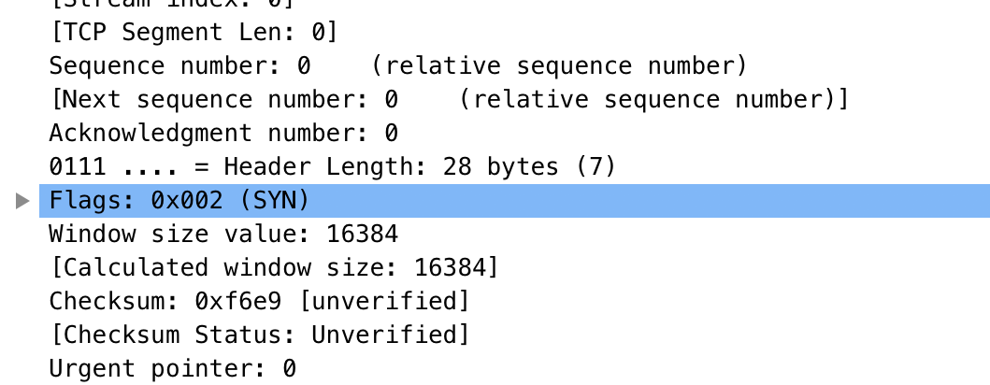

1. What is the sequence number of the TCP segment containing the HTTP POST command? Note that in order to find the POST command you will need to dig into the packet content field at the bottom of the Wireshark window, looking for a segment with a “POST” within its DATA field.

**164041**

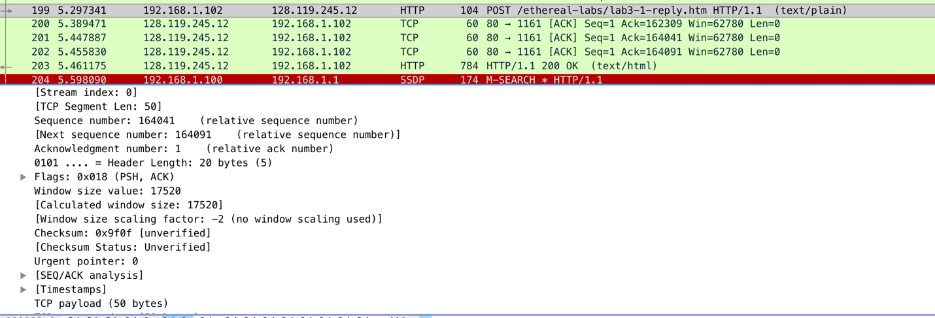

1. Consider the TCP segment containing the HTTP POST as the first segment in the TCP connection. What are the sequence numbers of the first six segments in the TCP connection (including the segment containing the HTTP POST)? At what time was each segment sent? When was the ACK for each segment received?

|  |  |  |  |
| --- | --- | --- | --- |
| Segment | Sequence Number | Time Sent | Time Received |
| 1 | 164041 |  | 09:44:25.867722 |
| 2 | Relative: 1; Ack #: 162309 |  | 09:44:25.959852000 |
| 3 | Seq: 1 |  | 09:44:26.018268 |
| 4 | Seq: 1 |  | 09:44:26.026211 |
| 5 | Seq:1 |  | 09:44:26.031556 |
| 6 | 164091 |  | 09:44:26.221522 |

1. Given the difference between when each TCP segment was sent, and when its acknowledgement was received, what is the RTT value for each of the six segments? What is the EstimatedRTT value after the receipt of each ACK? Assume that the value of the EstimatedRTT is equal to the measured RTT for the first segment, and then is computed using the EstimatedRTT equation shown below for all subsequent segments.

*EstimatedRTT = 0.875 * EstimatedRTT + 0.125 * SampleRTT*

Had trouble finding the RTT for packets, but discovered this graph. 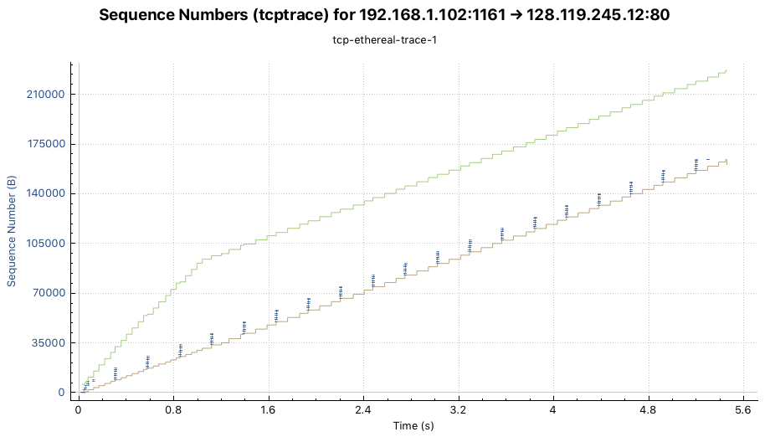

1. What is the length of each of the first six TCP segments?

This information was obtained from looking at the Length column of each packet.

|  |  |
| --- | --- |
| TCP Segment | Length |
| 1 | 104 B |
| 2 | 60 B |
| 3 | 60 B |
| 4 | 60 B |
| 5 | 784 B |
| 6 | 54 B |

1. What is the minimum amount of available buffer space advertised at the received for the entire trace? Does the lack of receiver buffer space ever throttle the sender?

**5,840 Bytes**

**No, the sender is never throttled.**

1. Are there any retransmitted segments in the trace file? What did you check for (in the trace) in order to answer this question?

**No. You can tell by checking for repeats in the sequence numbers.**

1. What is the throughput (bytes transferred per unit time) for the TCP connection? Explain how you calculated this value.

The throughput is the total number of bytes transmitted, divided by the transmission time.

Overall Throughput:

The total transmission time: 7.596 s

The total number of bytes: 177,851 B

Throughput: **~23.414 KB**

TCP Throughput:

Total TCP transmission time: ~5.455 s

Total number of bytes transferred: 164090 B

Throughput: **30.08 KB/ s**

This information was obtained from the capture properties, pictured below.

